THE GREAT PYRAMID EXTERIOR 1-22-14

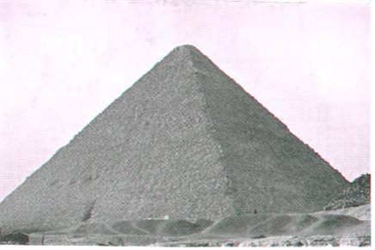

**((Use pan of approaching the Pyramids here.)**

As we approach the most recognized structures on Earth, the Pyramids of Giza, they seems to differ very little other than one is noticeably smaller and the largest one, titled the Great Pyramid, has no Apex or Chief Corner Stone that would elevate It so far above Its companions. In fact the center pyramid pictured below with its apex and casing stones on its upper portion still in tack, appears closer to completion than the largest or smallest of the three.

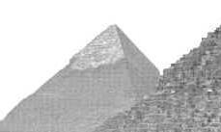

Many people visiting the Giza Plateau today, unaware of the Great Pyramids true identity, must wonder why this huge roughly stacked block structure was chosen as the First and Greatest of the Seven Wonder of the Ancient World. Looking no father the Great Pyramids outward appearance, which presently does not compare to the beauty or complexity to many of the early cathedrals, monuments, and statues throughout the ancient world, many observers are probably confused as to why the Great Pyramid was chosen as the 1st Wonder of the Ancient World while others may incorrectly assume Its massive size combined with the myth the Great Pyramid was the intended tomb for the Ancient Pharos Khufu or Cheops were the driving force which placed it the 1st Ancient Wonder of the World. To remove any doubt as to how It achieved this title will reveal the scientific and mathematical facts which set It apart from all structures in Earth including Its companions on the Giza Plateau. Amazingly this information, which has been available for over a hundred years, is not taught in schools or churches which clearly reveals the true identity of the Great Pyramid and why it is the Greatest Wonder of the World. To better understand what first brought attention to the Great Pyramid we will visit ancient documents from the 5th century BC and earlier which describes the Great Pyramid prior to being vandalized by the Arabs in the fourteenth century AD.



1. The Ancient people called the Great Pyramid Ta Khut, The Light, @ and Ikhet, meaning the Glorious, or The Glorious Light. These names were derived from the magnificent light shows, which could be seen for hundreds of miles, the Great Pyramid created when Sun rays were reflected from its four highly polished white limestone sides most vivid during the summer solstice.
2. It has been calculated these reflections were so intense they would have been visible from the Moon.

**** Master @ Mini Moc shows TGP reflections on Earth from behind the Moon. ****

1. One of the primary functions of the Great Pyramid in ancient times was to serve as a Sundial, not only of the day but to serve as a Sundial for the Seasons, indicating the annual recurrence of the principal points of the two forms of Solar year – the astrological and the agricultural. No form of building, unless accurately and symmetrically built with the proper reference to North, South, East, and west could be employed to serve this purpose.

DD p- 7

Master @ Mini Moc ****** (illustrate reflections with video here) ******

1. The illustrations below demonstrates how the Sun marked the Summer Solstice, the longest day of the year, as it passes directly over the Equator at midday. The Great Pyramid sits much further north, however it also marks this event due to its precise location, orientation, and the angle of Its sides allows the Sun’s rays pass just over the top of the Great Pyramid and down along its north face eliminating the shadow on its north face as the Sun’s rays are reflected upward into the sky. date__________.

** (DD P-20-23 Sundial P-7-19 show side view of Sun shining down its north face.)**

**(create video of this –job for Mini Moccasin)**

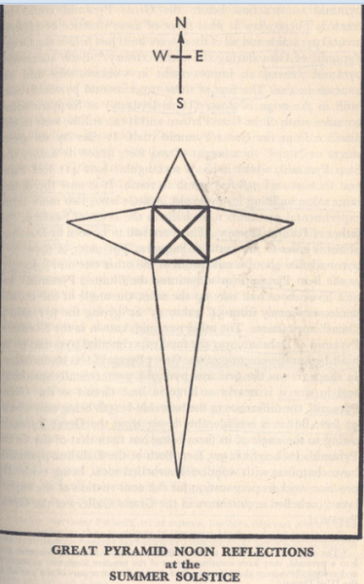 show side view also.

1. In the 5th century BC Herodotus, a Greek Historian regarded as the Father of History, wrote the earliest visual description of the Pyramid in which He stated all sides of the Great Pyramid were covered with highly polished casing stones with joints so fine they could hardly be seen yet its Top Stone was missing. He also described how the top-stone was the first of the exterior casing stones to be placed using the step sides of the Pyramids core as platforms to raise the Apex to its top position. The remaining casing stones would be placed as the Masons work their way downward to the foundation slab which would be the last stones placed.

**** show white limestone casing stones with joints the thickness of a hair****

6. In 60 BC Diodorus Sicurus tells us that in his day the Great Pyramid stood with its casing stones intact and was complete and without the least decay, yet it lacked its apex stone or Chief Corner Stone. With these two written accounts it is clear the Chief Corner Stone was never put in place as it would be impossible to remove a solid stone Apex approximately 30 ft. x 30 ft. x 30 ft. without removing the casing stones from one side of the Pyramid.

1. In 24 BC when Strabo wrote of the Great Pyramid, seemed like a building let down from heaven untouched by human hands. He also described the entrance to the Great Pyramid being on Its north face with a hinged door which could be raised, but was indistinguishable from the surrounding stones when closed. This will be further discussed when we discuss Al Mamoun’s attempt to find this door in 820 AD.

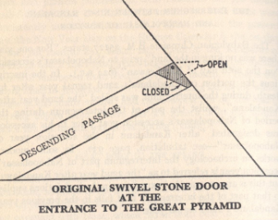

1. The companions of the Great Pyramid on the Giza Plateau were covered with granite casing stones shaped, polished, and placed with less precision than the white limestone casings on the Great Pyramid and were not capable of displaying the brilliant light shows described in the ancient records pertaining to the Great Pyramid. This is only one of the many extraordinary features which clearly set the Great Pyramid apart from It’s companions on the Giza Plateau.
2. The fact the Designer of the only stone structure on Earth to exhibit design and construction perfection with zero tolerance for error, both externally and internally, would intentionally change his flawless design during construction, according to the Rule of Purpose described in the Introduction of this Presentation, has to represent something of great importance. The fact these offsets of 286.1 inches each were held to the same zero tolerance for error and level of perfection as the Great Pyramids original design further confirms these changes were well planned to convey a specific message or important information to the Observer.
3. The offset of 286.1 inches, called the displacement factor, is first observed on the exterior of the Great Pyramids north face where the entrance to the Downward Passage is located 286.1 inches east of the Pyramids center line shown on the illustration below left. The red arrow on the photograph below right points to the location where Al Mamoun and his men initiated their forced entrance on the center line of the north face of the Great Pyramid below and about 24 feet east or right on this photograph of the original entrance to the Great Pyramids Downward Passage. The green arrow points to the original location of the Great Pyramids original Hinged Door Entrance.

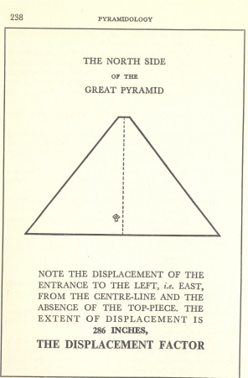 *BG #’s p-48 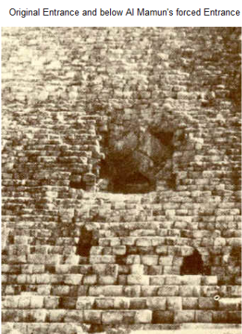

b. The Displacement Factor is also confirmed by the location of the Great Pyramids base sockets which extend past the exterior base line of the Great Pyramids lower casing stones, shown in the illustration and photographs below: **(photographs of sockets)**

We need to locate the n/w corner of the Great Pyramid over the n/w extreme of the n/w socket and overlay a ghosted Pyramid which has been stretched in size 286.1 inches to the south and east and see if it centers the interior passages and chambers of the Great Pyramid. This seems, without seeing it done, to better represent the Displacement that the version in Rutherford’s illustration. We need to see if moving the Pyramid this way closes the entrance to the subterranean chamber and pit.

1. The Displacement Factor is also represented at the Apex position of the Great Pyramid. ** (Place photographs and text pertaining to the external Displacement Factor here.)**
2. The Displacement Factor also appears in multiple locations in the interior passages and chambers of the Great Pyramid which we will cover in the Interior Segment of this Presentation. The fact this Displacement Factor is consistent in length, in all places where it is used, to the precision measurement of 286.1” proves without question it was intentional and represents an important event or message.
3. We will now redirect our investigation to review a second change the Designers allowed from His original plan, the omission of the Great Pyramids Chief Corner Stone, which is directly responsible for many of the amazing features illustrated throughout this Presentation and possibly the entire message the Great Pyramid was erected to deliver.
4. To intentionally omit the Chief Corner Stone, which exist on no other type structure and represents completion as It alone connects all of the Pyramids external sides, has to be an act of great importance.
5. The fact this Apex or Chief Corner Stone was omitted on what is otherwise the most perfect structure on Earth accents the importance of this change even more.
6. Throughout this Presentation will to reveal how the omission of the Chief Corner Stone and the location of the Great Pyramid verify Its message is intended for the people living on Earth today.

** (Show illustrations on the Chief Corner Stone) ** ** (Find out what a normal size apex would be a pyramid.)**

1. **( Quote from Scripture)**
2. The platform atop the Great Pyramid not being properly finished to accept the Chief Corner Stone is the first clue Its omission was definitely intentional.
3. The platform atop the Great Pyramid having no traces of residue from the adhesive used to secure the casing stones to these exterior limestone blocks further confirm the placement of the Chief Corner Stone was never attempted.
4. The previous evidence is further confirmed by the fact the Chief Corner Stone, the first casing stone to be placed, is missing yet all four of The Great Pyramids sides were finished to the level of perfection, described in #22 below, which cannot be duplicated by man today.
5. The omission of the Chief Corner Stone, which gives the Great Pyramid a total height of 5449 inches, is possibly the most important clue to positively confirm the true identity of the Great Pyramid as the Pillar at the border of Egypt described in Isaiah 19: 19 @20.
6. This scripture in Isaiah not only describes the Great Pyramids unique location, which takes an entire Segment of this Presentation to verify, Its Purpose which this entire Presentation just touches on, but Its numeric value of 5449 perfectly matches the height, in Sacred or Polar Inches, of the Great Pyramid with Its Chief Corner Stone missing. Shown in the illustration below. *(enlarge this illustration)*

13a. 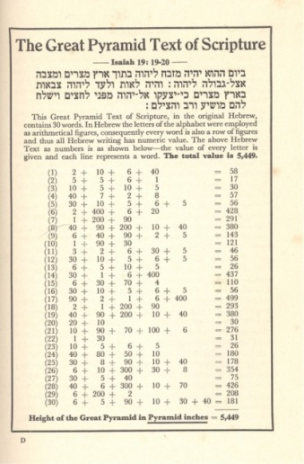 Place Isaiah script here in English.

1. We will now examine additional clues pertaining to the height of 5449 inches which further confirm the identity of the Great Pyramid as the Altar and Pillar described in Isaiah 19:19@20 and why Its Chief Corner Stone was rejected.
2. A one piece Chief Corner Stone for a 900 sq. ft. (give dimensions and estimated weight) would be extremely difficult if not impossible for the builders to raise over four hundred and fifty feet to Its intended position. ** (show illustration of the size of the Chief Corner Stone) **
3. * The small size of the casing steps at the Pyramids upper level, (give dimensions of smaller casing stone), which were used as platforms to raise the Chief Corner Stone, the first casing stone to be placed, into Its position further complicate this procedure. The remaining casing stones would then be placed in their positions as the builders worked their way down the sides of the Pyramid where they placed the larger base stones last.
4. It appears, for many reasons which we will pursue, the precise height of 5449 inches was of great importance to the Great Pyramids Designer, even if it resulted in the Builders rejecting the, Chief Corner Stone, which would be too large for the platform of the Great Pyramid. As we proceed throughout this Presentation it will become clear the Great Pyramid, with Its Chief Corner Stone missing, is a perfect reflection of the Earth with the Great Pyramid, a perfect Time Keeper, sitting at the exact center of its land mass.
5. The Hebrew language places numerical values to each of the letters in its alphabet rather than using the numbers 0 - 9 as does the English language. The illustration 13a displays Isaiah 19: 19 @ 20 in the Hebrew text, the numeric value of this text which has a sum of 5449, and the English translation of this text. As you read this text it appears to describe two completely different structures in separate locations: (1) a Alter to the Lord, which must be built of unhewn stone, in the midst of the land of Egypt. (2) a pillar, which can be built of hewn stones, to serve as a sign and a witness located at the border of Egypt. **( this seemingly impossible fact will be explained in the Interior Segment of this presentation)** The fact the numeric value of this scripture matches the exact height of the Great Pyramid with Its Chief Corner Stone missing in a measurement dimension, the Polar Inch, which is used only by the Jewish People, the British, the Descendants of the British, and has never been used by the Egyptians or any other Nation definitely places the duty of decoding the message of the Pillar to one of the Nations named above.

Book 1 P. 49

1. 5449 inches is the average elevation, above sea level, of all the lands on Earth. This point of interest is also described by Isaiah in 40:12. == English translation==

** (The Lord God hath “measured the waters in the hollow of His hand and … enclosed the dust of the Earth in a measure and weighed the mountains in scales and the hills in a balance”. **

1. The Great Pyramids position on Earth completes the description in Isaiah 40:12 as it divides the land surface of the world into two equal parts – All of the land east of the meridian on which the Great Pyramid stands being equal, within the limits of computation, to that west of the Pyramids meridian. This was discovered by Professor Piozzi Smyth, Astronomer Royal of Scotland. (Man’s ability to calculate this accurately has only been possible since the Earth has been mapped in a 3D format eliminating the possibility man, within the confines of Darwin’s Theory of Evolution, having the ability to located the building site for the Great Pyramid over four thousand years ago.
2. The Great Pyramids particular height of 5449 inches even takes into account the slight 296 to 297 irregular shape of the Earth. If you measure the circumference of the Earth at the Equator it has a ratio of 297 to the circumference measured around the poles of 296. As shown in the illustration below, if you were to place the moon on top of the Earth then place the Great Pyramid on the equator, with its projected Apex in position, and expand its base to equal the width of the Earth while keeping its height correctly proportioned Its Apex will hit the exact center of the moon. If the Earth was a true sphere this would not work as the apex of the Pyramid would protrude slightly past the center point of the moons equator as shown in the illustration to the right. This confirms the Designer of the Great Pyramid knew the exact out of round dimensions of the Earth and designed the Pyramids dimensions to represent those exact dimensions of Earth including its slight our of round shape.
3. 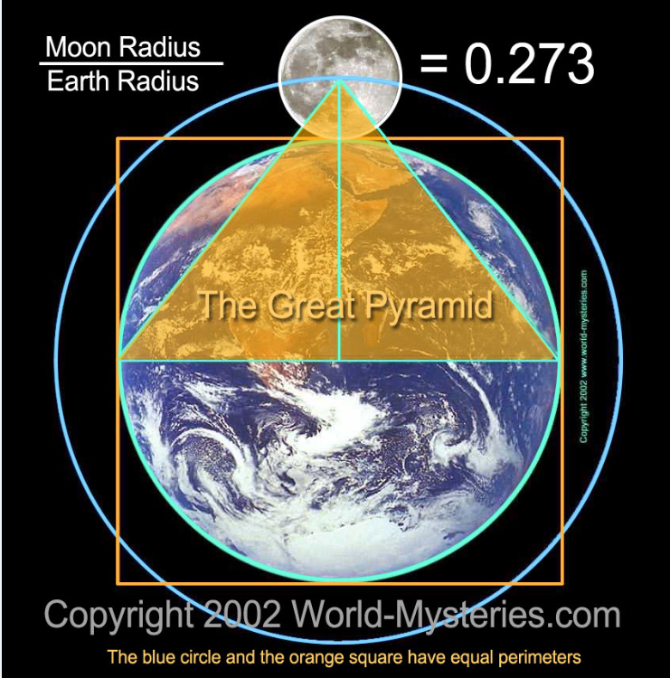 *(place illustration showing round Earth here.)*

29. Hebert L. Prout also confirmed the Designers knowledge of the Earths distorted shape which is illustrated in the (9th Clue) in the Location Segment of this Presentation.

30. In the sixteenth century, Girolamo Cardano, a brilliant Italian physician and mathematician concluded that the Great Pyramid embodied a system of linear measurement that had been derived from the Earth itself. He believed the size of the Earth had been known for thousands of years and that It too would be embodied in the Pyramid.

31. The slightly distorted shape of the Earth was first theorized by Sir Isaac Newton during his quest to compute the equation of gravity in the mid sixteen hundreds. Newton needed to know the exact circumference of the Earth to complete the formula for gravity and believed the Great Pyramid contained information which would assist him in calculating the Earths dimensions. While working on his calculations Newton realized the measurements of the Pyramid would be round numbers if the British inch was only a fraction longer. This observation confirmed the Sacred Inch or Pyramid Inch (1/500,000,000th of the distance between the North and South Poles) was the basic unit of measure needed to decode the scientific information designed into the dimensions of the Great Pyramid. Due to the debris which had accumulated around the base of the Pyramid the measurements available to Newton, at that time, obtained by Greaves @ Burattini were inaccurate and failed to give Him the answer he needed.

32. In 1637 John Greaves, a British astronomer and mathematician, went to Giza in search of the true circumference of the Earth which was believed by some to be designed into the exterior of the Great Pyramid. Unfortunately the depth of the debris at the base of the Great Pyramid also prevented Greaves from making an accurate survey of Its base and Cardanos’ theory was not proven at that time.

32a. It was later determined the length of each of the Great Pyramids four walls, when measured in a straight line corner to corner, is 9,131 inches in length which gives a combined total of 36,524 inches. Move the decimal point over two places and you get 365.24, the exact length of the solar year.

32b. The sum of the Great Pyramid’s two base diagonals in Pyramid inches equals the Procession of the equinox 25,827 years.

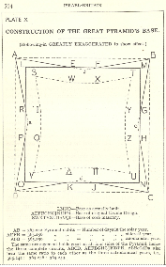 we will rescan this illustration Book 11 P-298

32b. The length of the Earth’s Sidereal Year, the actual time that the Earth takes to revolve around the Sun-measured by stellar observations is also represented at the base of the Great Pyramid. 32c. The period of the Earth’s Anomalistic Year (the time taken by the Earth to make a complete revolution in its orbit usually measured perihelion to perihelion, the distance when it is closest to the Sun. 32d. DD P-81-85 check how he explained this.

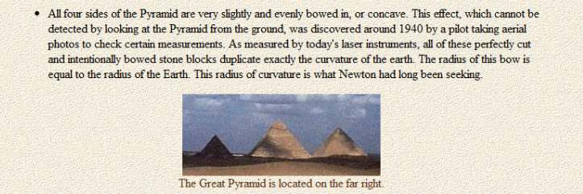

33. To better understand the impossibility of men fitting Darwin’ Theory or modern man of today accomplishing this one feat you must take into consideration the surface of water on a perfectly calm day is not level, as it appears to the human eye, but actually exhibits the curvature of the Earth no matter how large or small the surface area of the water covers. This curvature is detectable, by the human eye, as one views the Earths horizon over the ocean which displays one degree of curvature approximately every 69 miles. Even at the base of the Great Pyramid, which displays the longest point of its concave surface 7?? Feet, the inward curve is not detectable to the human eye. To further complicate the complex procedure of finishing the four faces of the Great Pyramid you must reduce this surface, from the over seven hundred feet width at the base of the Great Pyramid, to a single stone block 2 feet by three feet then cut and polish its surface to a undetectable curvature which must perfectly align with all stones that surround it. Now take into consideration this curvature extends over the entire face of the great Pyramid which means the center point of the bend is located in the center, left to right and up and down, of the entire wall on one individual block in the center of each of the four faces. This means each individual casing stone face regardless of size or position on the Pyramids face must perfectly continue the curvature in all direction from each of the stones it is connected to or the curvature will not hold true. This means no stone on each of the four sides of the Great Pyramid could be interchanged with a different stone on that same side or the perfection of this curvature would be compromised.

34. *** Later, in the 1800’s, it was proven the height of the Great Pyramid, with Its Apex missing, to Its base represented the same ratio as the circumference of a circle to its radius.

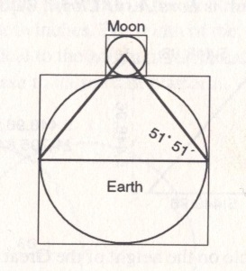

35. In the Bible, Christ refers to himself as “the stone which the builders rejected” Mark 12, 10. ** (quote verse) ** In this same verse of Scripture, our Lord describes the stone’s position as “the Head of the corner.” Applied to any ordinary building the words would be meaningless, for there is no such thing as a head corner-stone, but they aptly apply to the Pyramid’s top-stone, which is the head-stone of all the four corners. The top-stone of the Great Pyramid is therefore symbolic of Christ, who in the first instance was “the Stone which the builders rejected” but in due time is raised to His proper exalted position as the “Head of the Corner,” ** (place scripture here) **

36. (Dvarim / Deuteronomy 27:5, 6) “And there you shall build an altar unto Hashem your God, an altar of stones: you shall lift up no iron tool upon them. You shall build the altar of Hashem your God of unhewn stones.” And if thou make Me an altar of stone, thou shalt not build it of hewn stones; for if thou lift up thy tool upon it, thou hast profaned it.

37. In the Interior Segment of this presentation we will present evidence, the Designer and Builder of the Great Pyramid took great care to preserve the small natural cavern called the grotto, which gives the complete and perfect answer to this seemingly impossible discrepancy of how a single Structure could be referred to as an Altar and a Pillar.

38. Looking at the Great Pyramid today creates a far different impression than the perfection it displayed in ancient times, prior to its external casing stones being removed in the 14th century AD. The Photograph below shows some of the base casing stones which were uncovered by a work crew, directed by Colonel Howard Vyse, eliminating the question had they actually existed. These stones were polished to such perfection they displayed less than 1/100th of an inch variance on their entire outer surface of over 40 square feet in area on the larger base stones.

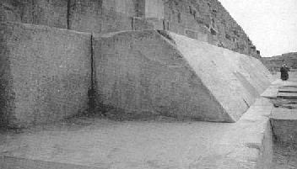

39. **Professor C. Piazzi Smyth, Astronomer Royal of Scotland, stated the joints are so close that - the edges of the two surfaces of worked stone and the filled of cement between, are comprisable - often within the thickness of a hair.

40. **Professor Wm. Flinders Petrie observed: To merely place such stones in exact contact at the sides would be careful work [because the stones are so large and heavy], but to do so with cement in the joints seems almost impossible. Later, commenting on the marvelous skill of the workmen in the placing of the casing stones, Petrie said: Their skill in cementing joints is hard to understand. How, in the casing of the Great Pyramid, they could fill with cement a vertical joint about 5 feet by 7 feet in area, and only averaging one-fiftieth part on an inch thickness is a mystery; more especially as the joint could not be thinned by rubbing, owing to its being a vertical joint, and the blocks weighing about 16 tons. Yet this was the usual work over 13 acres of surface, with tens of thousands of casing stones, none less than a ton in weight.

Reflections and Shadows of the Great Pyramid DD P-7 - 22

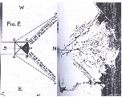

41. ** ((make a video showing a demonstration of this)) **

The illustration above demonstrates how on Nov. 1st, the commencement of the Season of Growing and New Year’s Day in the Early Kingdom, the Suns reflection pattern off of the polished exterior casing stones of the Great Pyramid perfectly defined the borders of the Nile Delta of Lower Egypt. This annual phenomenon physically confirms the location of the Alter to the Lord described in Isaiah 19:19@20 and the Great Pyramid of Giza are one and the same. (6d) We have read the descriptions of the external casing stones and how their level of perfection exceeds man’s capabilities today, representing the grandest Pillar on Earth to serve as a sign and a witness, yet the highest level of this structure, facing the heavens, is of un-hewn stone fulfilling the requirement of a Alter.

BELOW IS A GLIMPSE AT SOME OF THE INFORMATION REVEALED IN THE GREAT PYRAMID

1. The spherical shape of the earth, i.e. the exact amount to which the Earth deviates from the true sphere, owing to what is commonly known as “flattening at the poles” but which in reality is equatorial protuberance. Refer to the HUBERT L. PROUT ILLUSTRATION IN THE LOCATION SEGMENT

2. The long period of the revolution of the earth’s axis called by astronomers “the precession of the - equinoxes.” (Give the exact time app. 26,000 years) DD P-81-85 explained - 3. The exact length and elliptical shape of the Earth’s axis of rotation around the Sun.

DD P. 130

5. The illustration above gives a visual representation of the length and elliptical shape of the Earth’s orbit around the Sun.

(Will be demonstrated in the Exterior Segment - Plate XXV P 130 Davidsons Book TGP Its Devine Message)

***6. The mean distance of the Earth to the Sun. (show illustration and give distance)

***7. Volume of the Earth’s crust above mean sea level. (This may be in Pizza Smyth's Book?)

***8. The exact proportion of land and sea on the surface of the Earth as it is today, in the past Florida was approximately 800 miles wide near the Orlando area, additional evidence the Devine Message within the Chambers and passages of the Great Pyramid is addressing people of the present time. (Show maps)

*(Discovered by Pizzasi Smyth -Divided equally by the Great Pyramids longitude)*

***9. The value of Gravity for all latitudes on the Earth’s surface. (The value of gravity on the Earth’s surface varies with the latitude and to a very slight extent with the longitude according to the season of the year. Its law of variation is expressed as a mathematical function of the law of curvature of the Earth’s surface.) (Give chart)

***10. The weight of the Earth’ (give weight)

***11. The obliquity of the Ecliptic.

The Golden Number Book 11 P 292

Pyramid Angle Book 11 P-371

** Illustration Beginnings BG p-35 Earth and Moon dimensions

** Illustration of sockets AR Book 11 p-239

***photograph of sockets AR Book 111 p- 589 p- 520