Locating the Alter, Pillar, and Witness

Globe Turning



GREAT PYRAMID LOCATION 2-2-14

It seems logical the Designer of the most massive and precision constructed structure on Earth, the Great Pyramid of Gaza, would select a location equally special to place His Masterpiece. Perhaps 4,600 years ago the terrain surrounding the Great Pyramid appeared very different, but today the Great Pyramid is surrounded by barren desert on three sides and the densely populated city of Cairo to Its north. This setting, at first glance, does not seem to represent a location worthy of this Great Treasure and needs further investigation to determine whether or not our first assumption is correct. We will now examine the data concerning the location of the Great Pyramid which has been accumulated through many years of research to determine the significance of this particular location and why the Designer of the Great Pyramid chose this particular site. As we proceed through this Segment we will compare the findings pertaining to the location of the Great Pyramid of Giza to the location of the Altar and Pillar described in Isaiah 19: 19@20 and determine if They could possibly be the same Structure.

\*\* (place the script of Isaiah 19 verse 19@20 here) \*\*

If the evidence we review in this Segment proves the location of the Great Pyramid, the Alter, and Pillar is one and the same it will create an even larger question of how a Alter to the Lord, which has to be made of unhewn stone, can be the Pillar or the Great Pyramid which appear to be made of hewn stone.

We will initiate our review of this data from the upper platform of the Great Pyramid and determine what, from this vantage point, the evidence reveals.

 Place better photo here.

1st Clue. From the SE corner of the apex platform atop the Great Pyramid we will extend an imaginary line to its NW corner and continue this line far into the distance. We will now extend a second line from the SW corner of the platform to the NE corner and extend it far into the distance. Looking at the illustration below, due to the Great Pyramids perfect orientation to the four directions north, south, east and west, these imaginary lines encase the fertile lands of Lower Egypt’s Nile Delta.

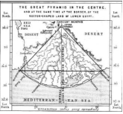 Better illustration scan needed.

The first person, in modern times, to discover this feature was Chief Hydrographor of the United States Coast Survey Henry Mitchell. When Mitchell realized the general curvature of the Nile Deltas coast formed a quadrant it inspired him to locate the point marking its Centre which, to his amazement, he discovered the Great Pyramid was sitting on the exact point of the quadrants Centre. Upon making this amazing discovery he exclaimed, “That monument stands in a more important physical situation than any other building erected by man.” It is the most accurately oriented edifice on Earth; its four sides face respectively north, south, east, and west while its two diagonals pointing north-west and north-east enclose the fan-shaped Country of Lower Egypt. This unique spot places the Great Pyramid at the border of Egypt where the governing Centre of this land, Cairo, is also located.

2ndClue. The illustration below shows a line drawn from the midway point of Lower Egypt’s costal border to the center point of the Great Pyramid equally divides Lower Egypt into two pie shaped halves which places the Great Pyramid in the Centre as stated in Isaiah 19: 19@20. This physically places the Great Pyramid of Giza in the midst, precisely on the midway dividing line, of the land of Egypt while being located on its border, or Giza, at the same time.

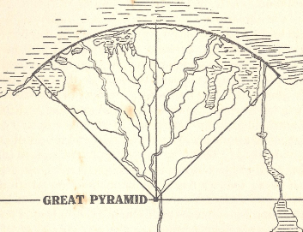 Place real map here then color each half different \*\*Big Shag\*\* 3RDCLUE. BLEED IN THE WORD GIZA -THE WORD GIZA MEANS BORDER IN THE HEBREW LANGUAGE.

\*\*(while the script is being narrated show lower Egypt as seen below and)\*\* : (1) SHOW LARGER MODEL OF PYRAMID IN POSITION FOR IDENTIFICATION THEN SHRINK IT BACK DOWN. (2) OVERLAY LINES POINTING N,S,E,@W TO SHOW ITS PERFECT ORIENTATION TO N S E W. (3) REMOVE LINES EXCEPT THE NORTH LINE TO SHOW THE DIVISION OF EGYPT. (4) COLOR EACH SIDE A DIFFERENT COLOR PLACING THE PYRAMID ON THE DIVIDING LINE OR MIDST. (5) COMPLETE THE CIRCLE AROUND THE NILE DELTA CONFIRMING THE PYRAMID IN THE MIDST.

A. B. 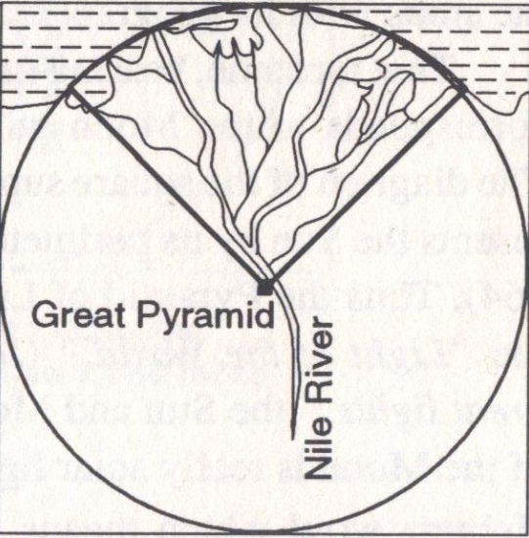

4thClue. If you continue the costal border of Lower Egypt keeping its angle of curvature consistent it will form a circle, as demonstrated in the illustration below right, placing the Great Pyramid in its exact center which describes the location of the Altar in Isaiah 19: 19 @ 20.

5thClue. The illustration below left reveals how the dimensional proportions of the moon compare to the dimensions of the circle formed when the curvature of the Lower Egypt costal border is continued back to its beginning.

6thClueThis illustration also documents the proportional relationship between the Earth, the Great Pyramid, the Moon and the circle surrounding the Great Pyramid.

7thClue. \*\*(Color Lower Egypt and the lower quadrant of the moon represented inside the proposed Apex of the Great Pyramid in light yellow, SHOWING THE QUADRANT MIRROW EMAGE OF EACH OTHER WITH THE SAME SIDE ANGLES OF 51 DEGREES 51’ 9.7” (CK THIS FOR ACCURACY), and the remainder of the circle a different color. Now rotate the circle surrounding Lower Egypt and place it over the illustration of the Moon.)\*\* work for the Big Shag\*\*

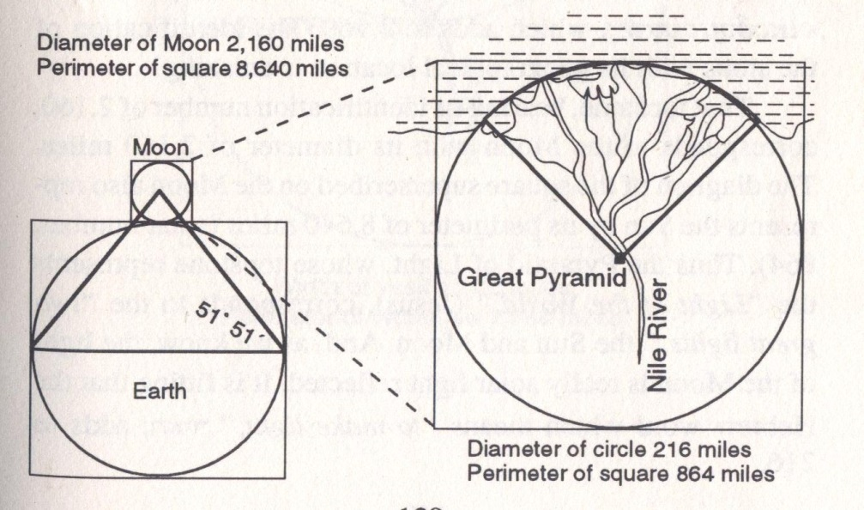

Fade in actual photos of the Earth and Moon into the illustration on the left \*\*Big Shag\*\* illustration

8thClue. The illustration below demonstrates how placing a right triangle of 26 degrees 18’ 9.7”, the exact angle of the Great Pyramids downward passage, ascending passage, and Christ Triangle, on the north face of the Great Pyramid with its hypotenuse extended into a northeast direction it will pass directly through Bethlehem, the birth place of Jesus Christ, the ancient crossing of the Red Sea, and the crossing point of the Jordan River. This illustration reveals a direct connection between the location, dimensions, and the orientation of the Great Pyramid, Biblical Events, and Jesus Christ Himself.

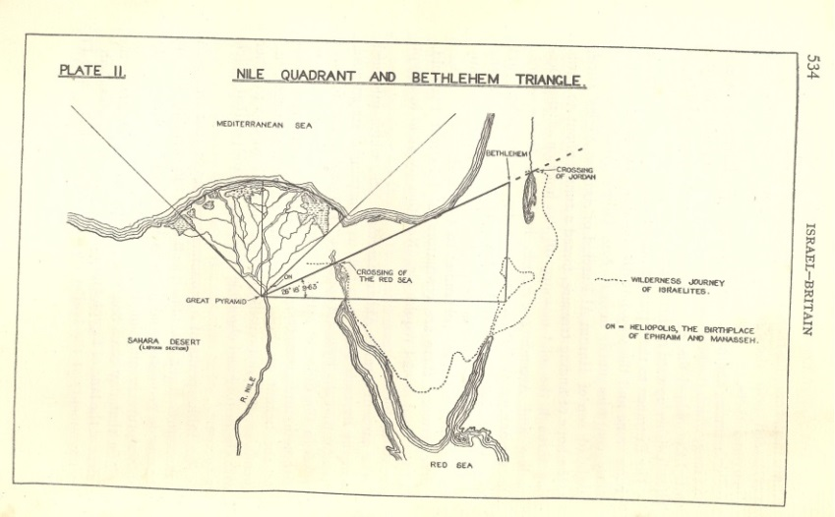

\*\*Book 11 P-340 Clean this illustration up. Possibly show a real map of this area. \*\* Big Shag\*\*

9thClue. 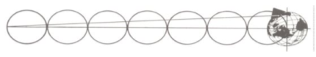 The out of round shape of the Earth, in the illustration above, has been exaurated for demonstration purposes due to the fact the ratio is too small to be seen with the human eye. This demonstration is the second example which proves the Designer of the Great Pyramid knew the exact amount the Earths shape varied from a sphere. In 1933 Hebert L. Prout discovered this feature regarding the location of the Great Pyramid. The slightly out of round shape described above is responsible for the polar axial diameter difference in length from the equatorial diameter by a ratio of 297 to 296. The Designers knowledge of the Earths slight out of round shape is positively reveal by its own location and precise latitude dismissing the possibility of its location being a coincidence. If an imaginary line is extended from the entrance of the Great Pyramid and its precise angle of 26 degrees 18' 9.7" are kept true this line will intersect the Earth’s axis of rotation at exactly seven Earth-diameters distance at the center of the Earth. A. If the Great Pyramid was moved just a hundred feet north or south this feature would be lost. B. If the earth was placed on its side and the distance between the Poles was used for the measurement scale the distance would be shorter than seven widths of the Earths Diameter. C. If the angle 26 degrees 18' 9.7", ?? the angle of all the descending and ascending passages in the Great Pyramid, was changed even by a fraction this alignment would be off. D. The entrance passage of the Great Pyramid becomes a pointer pinpointing its precise location on the face of the earth.

\*\*\*\*((we need to take a globe with a known diameter (297 TO 298 DIMENSION) and mark the exact location and orientation of the Great Pyramid using the angle of the downward passage measure 7 times its diameter ( WITH 297 AND WITH 298 FOR COMPARISON) = Mini Moc=

\*(We need to demonstrate the out of round shape with a globe –slightly exaggerated) \*\*Mini Moc\*\*

10thClue. To examine the next feature associated with the location of the Great Pyramid we will draw a parallel line beginning at the center of the apex platform of the Great Pyramid and travel in an eastern direction through Africa, Asia, and North America, and continue on until this line travels completely around the Earth back to its point or origin, the center of the Apex platform of the Great Pyramid. This parallel line will have traveled through the longest distance of land mass on Earth in an east / west direction, yet the total length of this line is shorter than the parallel line known as the Equator.

\*\* (show rotating globe with the Great Pyramid latitude line in green and Equator in red) \*\*Mini Moc\*\*

11thClue. Locating the center latitude line of the Earth, the Equator, would be possible for Ancient Man to accomplish by observing the shadow length of an object which protrudes perpendicular from the surface of the Earth. When the objects approaching shadow completely disappears on all sides of the protruding object for a short time and begins to appear on the opposite side of the object, it has marked noon of the Summer Solstice which takes place over the Earths equator. \*\*Mini Moc\*\*

\*\* (show illustration) \*\*

12thClue. The longest shadows from that protruding object in the north and south direction marks the date of the spring and Fall Equinox, which at their latitude positions display equal hours of hours of daylight and darkness. The location of these Equinox latitude locations could also be located by the same method used to identify the Equator. These actions will mark the location and date these events take place but do not indicate to an ancient observer whether the back and forth tilt of the Earth is changing the Suns position in the sky or if the Suns position in relation to the Earth is changing its position is responsible for the change.

\*\* (DEMONATRATE THIS WITH A ROTATING GLOBE MARKINT THE SPRING AND FALL EQUANOX) \*\*Mini Moc\*\*

13thClue. Even with this information and the invention of the sextant maps created well into the 18th Century were badly flawed as far as the shape, size, and proper location of the Earths land masses which was partly due to the limited ability of mappers to correctly position latitude lines, other that the Equator, Tropic of Cancer, and Tropic of Capricorn combined with the fact they had no method of locating longitude lines.

John Harrison 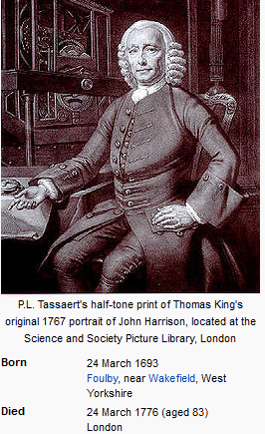

14thClue. Throughout the span of recorded history the search for a method to accurately locate longitude positions had overshadowed all Seamen. Latitude north or south of the Equator did not pose as great of a problem; it could be worked out, with a moderate degree of accuracy, by means of angular measurements of the Sun and stars with a relatively simple instrument, the sextant. However the ability to develop an instrument, a clock capable of keeping perfect time, to locate longitude positions had remained beyond the reach of even the most advanced scientist throughout the World.

15thClue. As it was stated to the members of the British government’s official Board of Longitude in 1714, by Sir Isaac Newton, “Such a Watch hath not yet been made.”

16thClue. It was not until the 1720's that, English clock maker, John Harrison began to design the Modern Worlds first instrument which would be capable of locating longitude points. Harrison completed the Chronometer #4 in 1761 and believed it was ready to be tested. John’s son, William, traveling on the HMS Deptford from Britain to Jamaica became the first successful test for such an instrument. During this nine day voyage only five seconds would be lost, making this one of the most important accomplishments of the time for sea navigation. The invention of the Chronometer gave Modern Man, for the first time in written history, the ability to accurately map the accessible lands on the Earth.

\*\* (show early Chronometer) \*\*

17thClue. Even with the Chronometer men would still need a method of transportation capable of navigating harsh terrain to map the entire Earth and gather the information necessary to precisely locate the construction site of the Great Pyramid.

1. The Wright Brothers did not complete the first airplane capable of lifting a man off the ground for a 12 second flight until Dec. 17, 1903. \*\* (Show photograph of plane.)\*\*

(b) It was 1904 before they completed a sustained flight of 5 minutes. \*\* (show film of flight) \*\*

(c) The first photographs taken from a flying apparatus were taken in 1858 by the French - photographer and balloonist Gaspard-Felix Tourna Chon over Paris France.

(e) The first multi-sheet topographic map series of an entire country, the Carte geometries de la - France, was complete on 1789 AD.

(f) 1913 saw the beginning of the international Map of the World initiative endeavoring to map all - of the Earth’s significant land areas at 1:1 million scale on about one thousand sheets covering - four degrees latitude by six or more degrees longitude.

(g) By the 1980’s centralized printing of standardized topographic maps began to be eroded by - databases of coordinates that could be used on computers by moderately skilled end users to - print or view maps.

(h) Older topographic maps were prepared using traditional surveying instruments while newer - ones use photogrammetric interpretation of aerial photography, LIDAR, and other remote - sensing techniques.

18thClue. The fact modern man’s ability to correctly map the Earths land masses has only matured within the last century removes any chance man, represented in Darwin’s Theory of Evolution, could have possibly located the construction site of the Great Pyramid over 4,600 years ago.

\*\* (show modern map and 1,500 hundreds map) \*\*

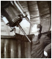 Abbe Murex \*\*(show animation)\*\* 19thClue In this animation we will start at the North Pole and highlight the longitude line which passes directly through the Apex of the Great Pyramid on its journey through Asia, Africa, Europe, and one half of Antarctica. The uniqueness of this longitude line is best described by Abbe Moreux, Director of the Bourges Observatory in France, as he states “The meridian line of the Great Pyramid, the line running north and south, passing through its apex is the ideal meridian; it is that which crosses the greatest amount of land and the smallest amount of sea.” \*\*Mini Moc\*\*

20thClue. This feature becomes even more amazing as you continue this line through the South Pole to the neither meridian, the meridian on the exact opposite side of the Earth, and continue to its point of origination at the North Pole. When this meridian is examined it will have passed through the greatest distance of water and the shortest distance of land on Earth. \*\*Mini Moc\*\*

21stClue. This not only places the Great Pyramid in the center and on the border of Egypt, but the exact center point of all the land masses on Earth.

22ndClue. This feature is further documented on the flat map below, created by the U.S. Navy , from fragments of the Ancient Piwi Reis map.

\*\* (show modern map of the Earths land masses and the Great Pyramids location) \*\* 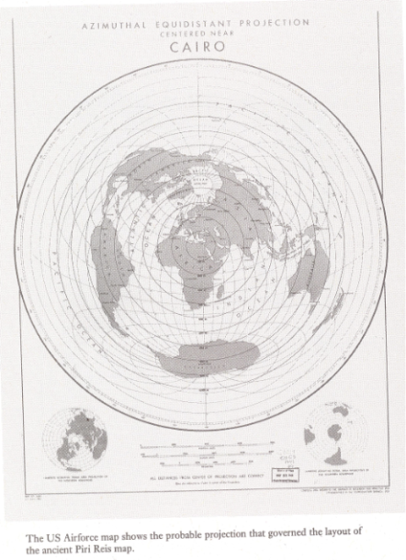place modern map here

The Piwi Reis map, from the 1,500’s AD, was derived from much earlier maps dating back to the Library in Alexandria not only aligns with the modern maps of North America, South America, and Africa it shows Antarctica when it was free of its present ice cover. For some reason the early European Explorer’s searching for new lands to the west were not aware of this map, which is equal in accuracy to many modern maps today, further documenting the missing gap of time in Darwin’s Theory. \*\*((explain the origin of the Piwi Reis map in more detail))\*\*

 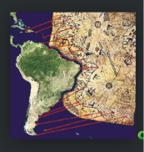 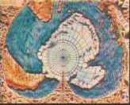

Piwi Reis map in green Piwi Reis map in tan Piwi Reis map showing Antarctica

22ndClue. To further confirm the Great Pyramid being the Center point of the entire World observe how the land masses on Earth are randomly placed over the entire Globe and not centered in any order pertaining to the location of the Equator or either of the Poles yet all are centered precisely around the Great Pyramid. \*\* (fade in the equator on the above map then show the Pyramid Latitude and Longitude lines) \*\* Big Shag\*\*

23rdClue. The complexity of this clue is elevated even further when the fact the Earth is not a true sphere is added to the equation. The Earth bulges at its equator which causes a slight flattening phenomenon at each pole. This feature, first theorized by Sir Isaac Newton, is caused by the expansion of the Earth molten core reacting to the speed of the Earth’s rotation which reaches the speed of approximately one thousand miles per hour at the equator. \*\*Mini Moc\*\* show measurement of Earth N/S and EW

\*\*\*\* ((stop the globe at the location of the Great Pyramid place a colored line marking the distance of land in one color and the open water in a different color then start the globe rotating in the eastern direction, place a percentage digital counter on each line to calculate the land and water lengths to verify the land distance that is greater at the Pyramids location and the water distance that is greater on the neither meridian line. Mark the meridian where the water is at its greatest distance as the rotation continues around the globe. When the rotation is completed rotate the Earth in the north south direction which will show these two lines form a complete circle around the Earth. \*\*Mini Moc\*\*

24thClue. The circle around the Earth which is formed when these opposing meridian lines, described in Clues 19@20, meet divides the Earths land mass into two equal halves, within the limits of computation, a fact discovered by the Astronomer Royal of Scotland, Professor Pizzai Smyth. \*\*Mini Moc\*\*

25th Clue. The description of this discovery is stated in the Bible proving once again the Designer of the Great Pyramid knew the exact dimensions of the Earth thousands of years before it was discovered by modern man.

\*\* (Isaiah 40:12 The Lord God hath “measured the waters in the hollow of His hand and enclosed the dust of the Earth in a measure and weighed the mountains in scales and the hills in a balance”.)\*\*

26th Clue a. This feature is further confirmed by the fact the height of the Great Pyramids summit is 5449 inches which is also the average height of the Earths land masses above sea level and the numeric value of the Bible verses of Isaiah 19: 19 @ 20. \*\*show cross section of the Earth accenting the highest point Mt. Everest and the lowest point then melt them into a layer the height of the Great Pyramid which will be a different color\*\* Big Shag\*\*

275hClue b. The feature described above, along with others which we have discussed earlier, and some we will cover later would not exist if any part of the Earths land masses were proportioned or located differently than they are today. The evidence revealed below indicates the message of the Pyramid was intended for the people living as the Earth exist today.

28thClue. Evidence does exist, of which we have two examples listed below that indicate at one time portions of the Earth’s surface, if not its entire surface, were very different than they appear today. Many, who cannot accept Creation as the origin of man, believe these changes took place millions of years prior to the Great Pyramid being built while other evidence like the Holvind Theory and the Timeline of the Great Pyramid indicate these changes were caused by the Great Flood, after the Great Pyramid was built, which conformed the Earths exterior to match the design and dimensions of the Great Pyramid exposing Its true Identity and Designer.

1. Archeological and fossil evidence validate Florida’s peninsula, long before the flood, was over 800 miles wide.

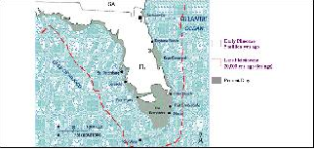\*\* (place evidence here) \*\*

(2) Petrified clams and other sea dwellers have been recovered near the summit of Mt. Everest, the highest point on the entire planet and other mountain tops throughout the world proves these peaks were either covered with water as mountains or were formed as mountains by some catastrophic event which rearranged the Earth surface. When a clam dies its muscles immediately relax and the clam shells open, you seldom if ever find a dead clam which is in the closed position on a beach or river bank. In order for a clam to petrify in the closed position it would have to be covered with soil which contains the proper minerals necessary to replace the shell as it decomposes before the clam died. The facts many petrified clams are located near the summit of the world’s tallest mountain and many other mountain peaks throughout the world strongly indicates these mountain were formed by a violent shift of the Earth’s surface rather than these mountains being covered with water at their present altitude.

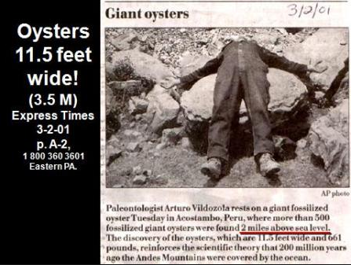

?? 29thClue. The map below gives a visual observation which confirms if the Great Pyramid was located slightly further south the latitude line which passes through the center of its upper platform would be located in the Gulf of Mexico below the Florida Panhandle, as it exist today, eliminating this line passing through the longest landmass in an east west direction.

\*\* (Place Gulf of Mexico map showing the Panhandle of Florida here) \*\*

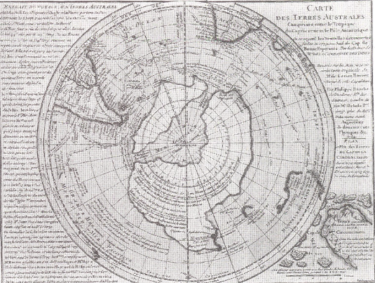

30thClue. The Oronteus Finaeus 1531 AD map above, also drawn from earlier maps, clearly show Antarctica, correctly positioned, as it would look free of ice. This map matches the land configuration and contours of modern seismograph readings yet it was drawn centuries before this this type equipment existed, which creates three contradictory propositions for our modern scholars to choose from:

31stClue. The map below is an early nineteenth century Russian map which shows the very southern portion of the Earth missing due to the fact Antarctica was not discovered by modern man until 1818 AD.

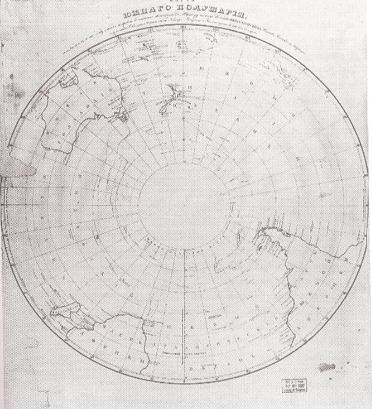

\*\* (fade in the map of Fl. Panhandle here) \*\*

32ndClue. The task of accurately mapping the entire Earth’s surface, which was necessary to position the Great Pyramid and Stonehenge, working from the ground level even with the chronometer would still be impossible. The land surface in many areas of the world is simply impossible to navigate with any type land travel including by foot. The distance between Meridian lines vary according to their location between the equator and the Earths Poles. The distance between Longitude lines narrow as they approach each Pole where they join and become a single a dot decreasing their speed of rotation until no noticeable movement can be detected by the human eye. The opposite happens as they approach the equator where their speed accelerates to its maximum speed of nearly one thousand miles per hour and the distance between them reaches their maximum width. As these longitude lines cross the Equator on their way to the opposite pole the distance between them and their speed starts to decrease on their journey toward the opposite pole. A method of keeping accurate time is necessary to plot longitude lines as they are spaced to represent the correct hour of the day from any location on Earth twenty four hours a day. To locate the longitude line passing through the greatest distance of land mass on Earth and the longitude line which passes through the shortest distance of water and pinpoint the exact center of the Earth’s land mass the surveyor would have to possess an accurate map of the Earth, have the ability to produce aerial photographs, or have some other method of knowing the exact layout of the entire Earth. Using Darwin’s Theory of Evolution as a road map of human development Aliens or the Creator of the Earth are the only options which could have found this location.

1. If Antarctica has been covered with ice for 15,000 years as estimated by some Experts or’ millions of years taught by some Orthodox Geologist it would be impossible for low-browed knuckle-dragging hominids, which Darwin’s Theory describes them at this time, to create such a detailed map as the one shown above. This means there has to be a missing gap of time, at least 15,000 years ago, in which a far advanced group of people were present on Earth to create these maps. (2) Alien cartographers using space craft created these maps, thousands of years ago, before Antarctica was covered with ice. This would leave the second question of who kept these maps until the knuckle draggers advanced to the level they understood them and why were the European Explorers not aware of these maps as they searched for new lands to their west. (3) The Creator of the Earth intentionally caused this catastrophic change which rearranged the entire Face of the earth as the Bible states. He also designed the Great Pyramid, hundreds of years prior to this Flood, to perfectly represent the Earth as it would appear long after the great transformation took place for It to be unquestionably recognized by the intended recipients’ of Its message, as stated in Isaiah 19: 19@20.

(3a) One theory, which seems to be confirmed by credible evidence, as to how the Creator orchestrated this catastrophic event is referred to as the Holvind Theory. This Theory states fragments from a disintegrating comet attracted to the magnetic field surrounding the Earths Polar regions impacted the Earth with such violence it rocked the Earth off its upright position. This collision immediately changed the angle of the Earth’s axis alignment as the Poles were with over a mile of ice in places. We will now show some of the evidence which led Ken Holvind to believe this event was the method the Lord used to create what is referred to in the Bible as Noah’s Flood. Thousands of mammoths, referred to as Woolly Mammoths, have been discovered in the Siberia and other areas of the Earths north polar region which died of suffocation not hypothermia. Some of these Mammoths have been recovered which were frozen in the standing position with vegetation in their stomachs which was only partially digested.

33rdClue. \*\* (research further) The illustrations below, which has been challenged as to its precision match by some will be further discussed as a point of interest, demonstrates how the Pyramids of Gizeh and their alignment to each other closely resemble the positions of the stars in the belt of the Orion. This similarity to the Orion Constellation is further supported by the fact two other Pyramids location also fit the star pattern of Orion, Nebka at Abu Rawash perfectly reflects the star Saiph, while the pyramid at Zawat al Aryan’s location matches the star Bellatrix of the Orion Constellation indicating a possible connection between the Pyramids and Orion. We will show much more evidence Orion is associated with the Great Pyramid when we review the Interior Segment of this presentation. \*\* (put arrows pointing to the two stars) \*\*

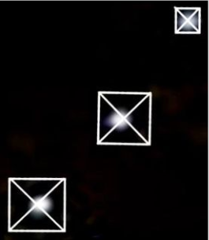 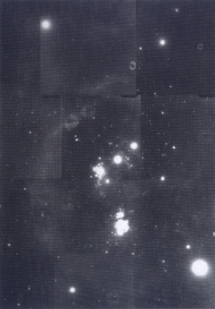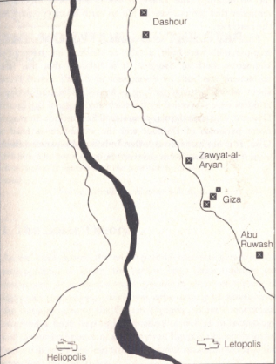

34thClue. The diagram below shows a sequence or raised steps, which are offset to the north, in the bedrock of the Great Pyramids foundation. The fact the bedrock below these steps appears solid indicates the Designer went to great lengths to preserve what appears to be the only flaw in the entire foundation of the most massive structure on Earth. This small cavern had to be of great importance for the Designer to adjust the Pyramids foundation in order to preserve this flaw.

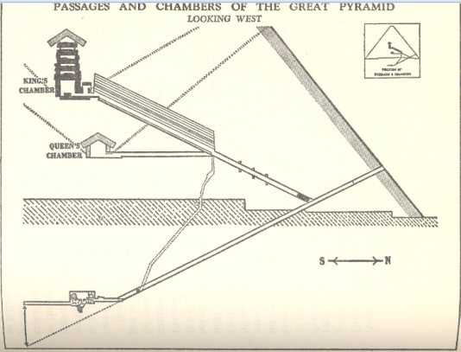

35thClue. The illustration below is a cross section of the Great Pyramid, looking from south to north, which shows the Great Pyramids descending passage system, Its ascending passage system, and chambers which are all perfectly positioned to align with the small natural cavern called the grotto. The fact this cavern existed before the Great Pyramid was built and the Designer of the Great Pyramids would take such care to perfectly align the interior of this massive structure with this small cavern has to be of great significance. We will cover this small cavern, its contents, and how it is accessed more thoroughly in the Interior Segment of this presentation. If the evidence in the Interior Segment proves the grotto has significant meaning and It’s align with the passages and chambers of the Great Pyramid was necessary this one feature alone will lock the location and orientation of The Great Pyramid to this precise spot on the Earth.

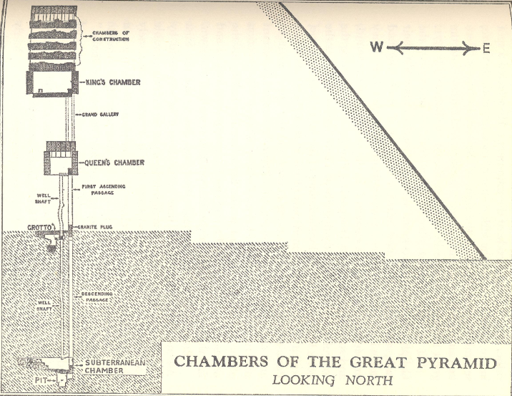 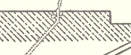

36thClue a. On the Salisbury Plaines of Southern England stands a strange looking structure, Stonehenge, which was used for centuries by the Ancient People, as was the Great Pyramid, to determine planting seasons and other activities just. Stonehenge is considered to be the most precise solar observatory of the ancient world.

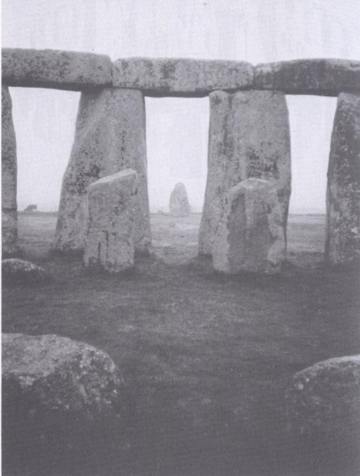 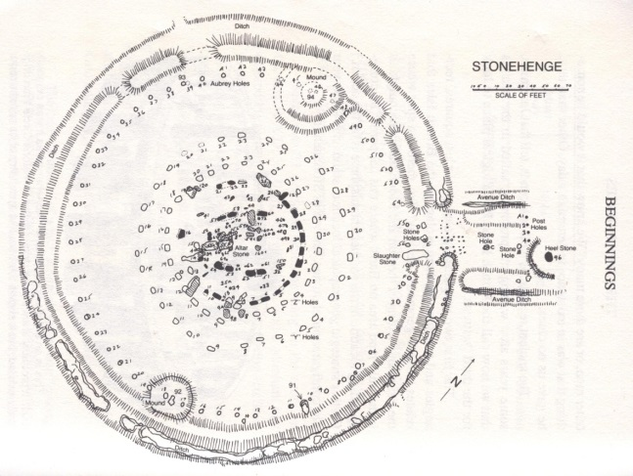

As knowledge in math, history, and the sciences advanced it became evident to the British People’s the complexity of this structures design far exceeded the requirements necessary if it was to be used for a Sun Dial alone. It was also obvious the scientific knowledge and mathematical skills necessary to design this structure were far advanced from what history teaches these Ancient People would have possessed thousands of years earlier when this structure was erected. This conclusion initiated many years of research by some of Britain’s leading scholars and an American, the late Bonnie Gaunt, to many amazing discoveries pertaining to the significance of its location, design, precision orientation, alignments with our solar system, and its true purpose. We will cover several of these discoveries in the Interior segment of this presentation, but first we will validate the accuracy of its construction, orientation, and its connection to the Great Pyramid.

37thClue. The illustration below demonstrates how the center point of Stonehenge serves as crosshair for the parallax of the Sun rises and settings and Moon raises as they align with specific marker stones within this structures layout. The Architect of Stonehenge chose the only location on Earth this structure can be placed without altering its shape as its matching location in the southern hemisphere is in the ocean.

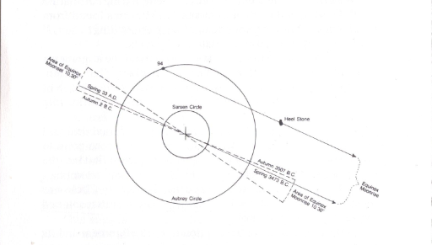

The fact these rises and settings specifically aligned with these marker stones and their parallax all cross the center point of the Stonehenge structure locks the shape, design, size, orientation, and precise location of Stonehenge to this one spot on Earth. If Stonehenge as it presently appears was moved or rotated even the slightest distance these alignments with the Moon and Sun would be lost as would other amazing information revealed in its dimensions. In the 1950's Professor Gerald Hawkins, an astronomer from Boston University, went to Stonehenge to study and record the relationship of the Sun and Moon movements to this ancient structure and determine what they meant. When Professor Hawkins returned from England and programed the information he had gathered into a computer, he was overwhelmed with the evidence; it had taken the invention of a computer to calculate what his observations and recordings revealed. Professor Hawkins found 12 significant alignments pointed to an extreme position of the Sun and 12 more pointed to an extreme position of the Moon. He was so impressed with these findings he calculated their probability of being coincidence which came to one in ten million.

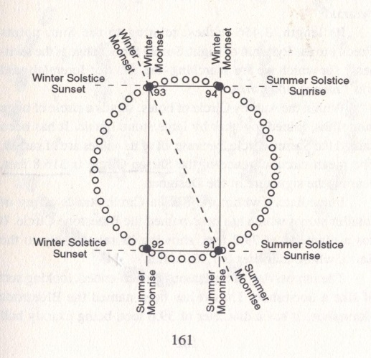

38thClue. The illustration below demonstrates how the azimuth of Sunrise has gradually changed through the centuries due to the Sun slowly slipping back along the ecliptic. This change is caused by the gradual rising upward of the Earth’s axis, presently 23.5 degrees of angle, which is also responsible for the Winter Solstice date changing from December 25th, which was the shortest day of the year, to Dec. 21st and some years Dec 22nd. This rising of the Earth on its axis, according to the Holvind Theory, is partly responsible for the Earths warming temperature which we will cover later in the Interior Segment of this presentation.

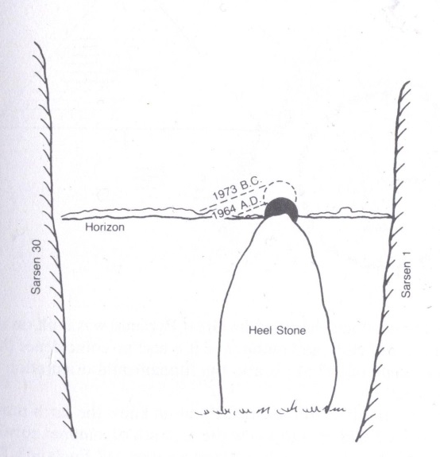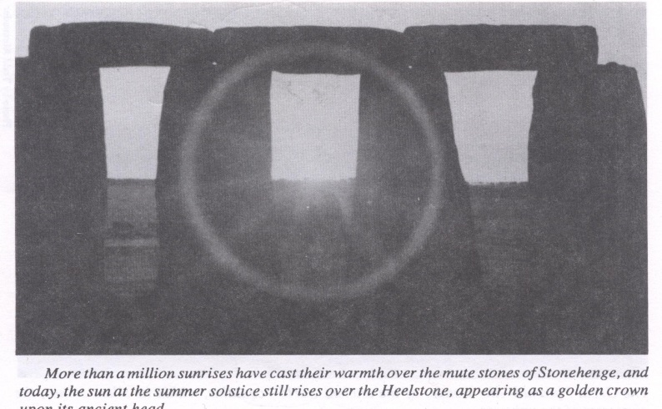

36thClue. The illustration below documents a definite connection between Stonehenge and the Great Pyramid of Gizeh. 1st. Extend a base line from the center point of Stonehenge over the Heal Stone in the direction of the Summer Solstice Sunrise. 2nd. Extend a second line from the center point of Stonehenge in the direction of true north, the hypotenuse of this right triangle will be the same angle, 51 degrees as 51' 14.30645", as the exterior sides of the Great Pyramid. Let it also be noted the Great Pyramid is the only Pyramid in Egypt which displays this exact angle on its sides positively connecting Stonehenge to this particular Pyramid.

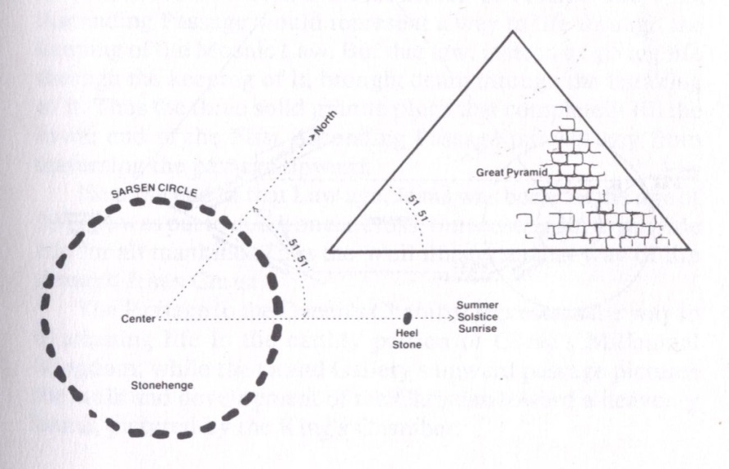

37thClue. The illustrations @ photograph below further confirms Stonehenge’s location, design, dimensions, and perfect alignment with the Summer Solstice Sunrise are crucial for the line starting at Station Stone 93 to cross the center point of Stonehenge, pass over the top of Station Stone 91, and continue for 2,235 miles and hit the Great Pyramid of Gizeh directly on its north face wall. This demonstrates the amazing accuracy used in positioning these structures thousands of miles apart on an out of round Globe. If either of these structures were moves or oriented even the slightest fraction of a degree this line would completely miss the Great Pyramid. \*\*( show illustration)\*\*

38thClue b. If the distance, \*284 feet, between the exact centers of Station Stone 93 and Station 91 represented the length of a rifle barrel aimed at the Great Pyramid which has a base width of \*755 feet the barrel of the rifle would miss the Pyramid if it was just xxx degrees off. \*\* Mini Moc\*\*

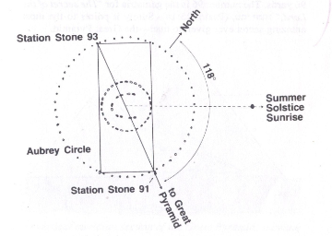

\*\* (place aerial photograph of Stonehenge and the Great Pyramid with LINE BETWEEN THEM.)\*\*

39thClue The following illustrations, from books by the late Bonnie Gaunt, show the location and dimensions of Stonehenge, the Great Pyramid, the Moon @ the Earth validate the same Designer is responsible for both Structures.

40THClue. The illustration below gives mathematical similarities between the Earth, Moon, the Great Pyramid, and Stonehenge which further strengthens the ties of the British or Anglo Saxon Race and Stonehenge to the Great Pyramid,.

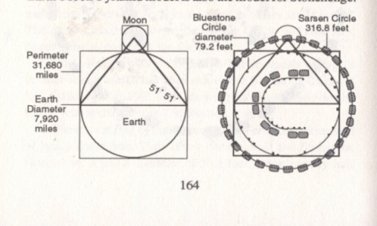 \*\*Repeat function above then fade in Stonehenge\*\* Big Shag\*\*

41stClue.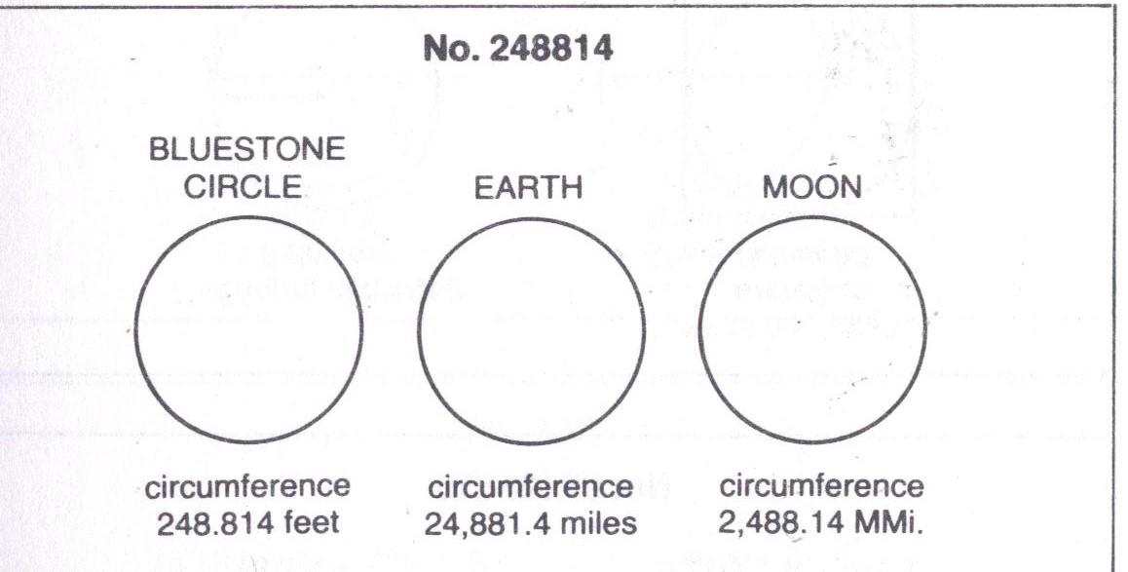

The illustration above using the dimensions of the Bluestone Circle of Stonehenge, the Earth, and the Moon further confirms the mathematical connections between the design of our Solar System, the Great Pyramid, and Stonehenge.

42ndClue. 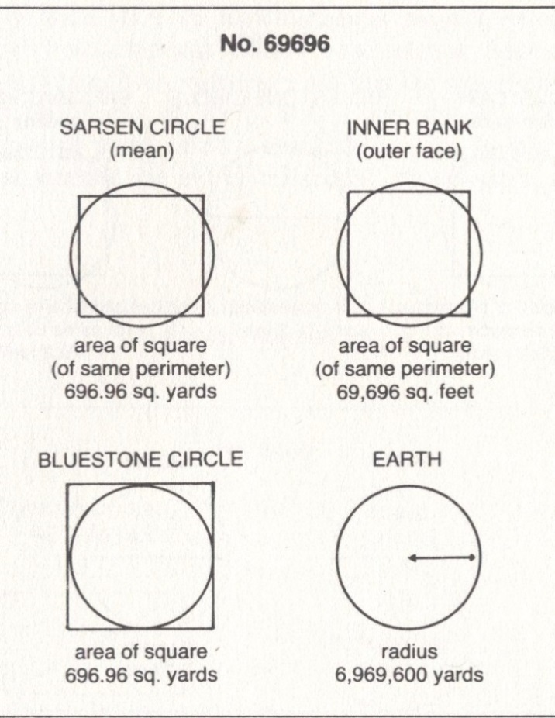

43rdClue. 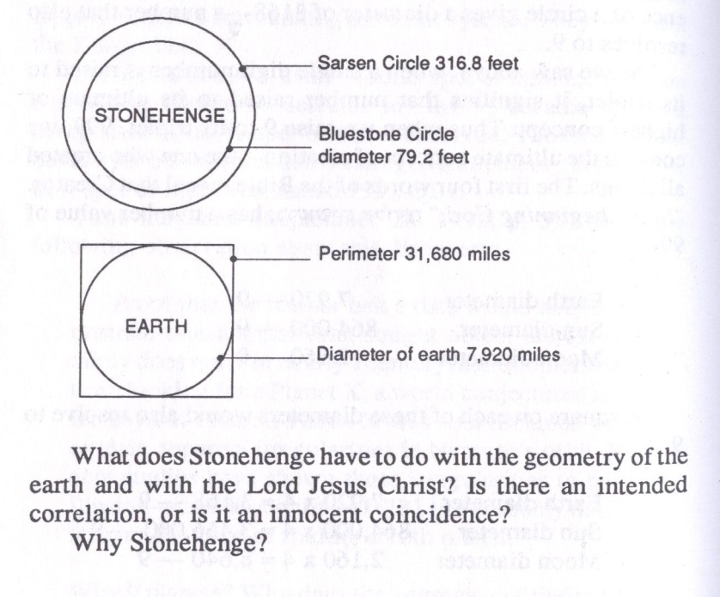

44thClue. The fact Stonehenge and the Great Pyramid could only be decoded by someone who used the inch as the basic unit of measure, was given liberal access to these Structures, had advanced knowledge of the Universe, and was dedicated to the belief Jesus Christ was the Son of the God Jehovah pinpoints the present time and British Race or their Descendants to the task of decoding these structures.

As we review the information in the Exterior and Interior Segments of this Presentation information even more amazing than what we have witnessed this far will appear.

.